|  |  |
| --- | --- |
|  |  |
|  | Foundation Activity 2 LED Light Circuit |

Circuit Diagrams

Diagrams use symbols to represent circuits that we can build in the real world.

|  |  |  |  |
| --- | --- | --- | --- |
| **Image** | **Symbol** |  |  |
| **C:\Users\Harryp\MEGA\Surface Pro 2\Nepal\Himalayan Makers Guild\Activities\Foundation Activities\FA2 - LED Circuit on a Breadboard\images\2018-04-29 17_48_15-Untitled Sketch.fzz_ - Fritzing - [Breadboard View].jpg[[1]](#footnote-1)** |  | *Battery* | The voltage source for the circuit. |
| **C:\Users\Harryp\MEGA\Surface Pro 2\Nepal\Himalayan Makers Guild\Activities\Foundation Activities\FA2 - LED Circuit on a Breadboard\images\part jumper.png** |  | *Wire* | A pathway for current to move along. |
| **C:\Users\Harryp\MEGA\Surface Pro 2\Nepal\Himalayan Makers Guild\Activities\Foundation Activities\FA2 - LED Circuit on a Breadboard\images\2018-04-29 17_48_25-Untitled Sketch.fzz_ - Fritzing - [Breadboard View].jpg** |  | *LED* | Light Emitting Diode. Current will only flow in one direction, where the “arrow” is pointing. |
| **C:\Users\Harryp\MEGA\Surface Pro 2\Nepal\Himalayan Makers Guild\Activities\Foundation Activities\FA2 - LED Circuit on a Breadboard\images\2018-04-29 17_48_58-Untitled Sketch.fzz_ - Fritzing - [Breadboard View].jpg** |  | *Resistor* | Limits the flow of current through the circuit. |
| **C:\Users\Harryp\MEGA\Surface Pro 2\Nepal\Himalayan Makers Guild\Activities\Foundation Activities\FA2 - LED Circuit on a Breadboard\images\2018-04-29 17_49_04-Untitled Sketch.fzz_ - Fritzing - [Breadboard View].jpg** |  | *Button* | Like a door for current to flow through. When the button is pressed, the circuit is connected and current will flow. |

This is the circuit we will build to light up the LED:

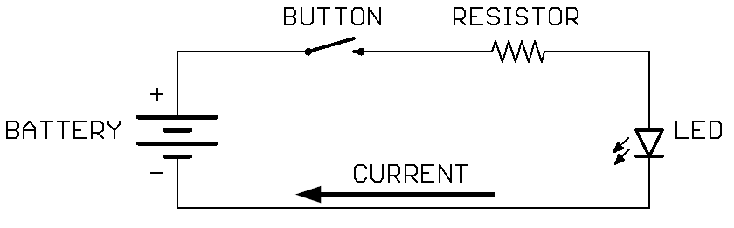

Building Circuits on a Breadboard

|  |  |
| --- | --- |
|  | Breadboards are used to build circuits that can be put together and taken apart without needing special tools.  Parts inserted into the same line are electrically connected by metal inside the board. |

|  |  |
| --- | --- |
| Parts inserted in **different** lines. They are **NOT** connected. | Parts inserted on the **same** line. They **ARE** connected, making a node. |
| C:\Users\Harryp\MEGA\Surface Pro 2\Nepal\Himalayan Makers Guild\Activities\Foundation Activities\FA2 - LED Circuit on a Breadboard\images\breadboard example 3.jpg | C:\Users\Harryp\MEGA\Surface Pro 2\Nepal\Himalayan Makers Guild\Activities\Foundation Activities\FA2 - LED Circuit on a Breadboard\images\breadboard example 4.jpg |
| C:\Users\Harryp\MEGA\Surface Pro 2\Nepal\Himalayan Makers Guild\Activities\Foundation Activities\FA2 - LED Circuit on a Breadboard\images\breadboard example 2.jpg | C:\Users\Harryp\MEGA\Surface Pro 2\Nepal\Himalayan Makers Guild\Activities\Foundation Activities\FA2 - LED Circuit on a Breadboard\images\breadboard example 5.jpg |
| One part inserted with **both ends** inserted in the **same** line will **NOT** work. C:\Users\Harryp\MEGA\Surface Pro 2\Nepal\Himalayan Makers Guild\Activities\Foundation Activities\FA2 - LED Circuit on a Breadboard\images\breadboard example 1.jpg  Because the two pins of the LED are connected in the same node, there will be no voltage difference between them, so no current will flow from the (+) pin, through the LED, and out the (-) pin (a flat hill in the rockslide analogy of electricity). If we connect this circuit to a voltage, current will flow around the LED through the low-resistance metal of the breadboard (like a wire). | |

Remember: 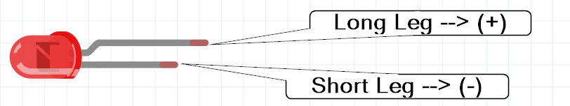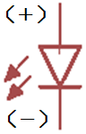

1. Part images from Fritzing, except the wire. [↑](#footnote-ref-1)